STX-5013, SPRO-5013 Slim LCD Phone
Instruction Manual

Introduction
Thank you for purchasing the Slim LCD Phone, enabling you to make and receive Skype calls right on your computer or laptop. The Slim LCD Phone works like your ordinary phone and rings for all incoming calls. You can select people to call from the Skype contact list or press SkypeOut numbers to make calls on the phone. With LCD, keypad and ringer, it is just like using your regular phone.

1.1 Features
1. Easy to use like a regular phone
2. Phone rings for all incoming calls, ring style selectable
3. Unique slim design for maximum comfort
4. Dial Skype™ contact and SkypeOut™ number from phone keypad
5. Echo cancellation, noise reduction, duplex communication
6. Driver and sound card built-in, no external power required

1.2 System Requirements
PC with the following minimum requirements:
- Pentium 3® or equivalent based processor
- 256 MB RAM
- Windows 2000® / Windows XP® / Windows Vista™ Operating System
- One free USB port
- Any broadband connection or minimum 33.6 Kbps dialup

1.3 Package Contents
1. One Slim LCD Phone
2. One user manual
3. One installation CD
4. Skype Voucher

2 Using the USB Slim LCD Phone

2.1 Keypad Instruction

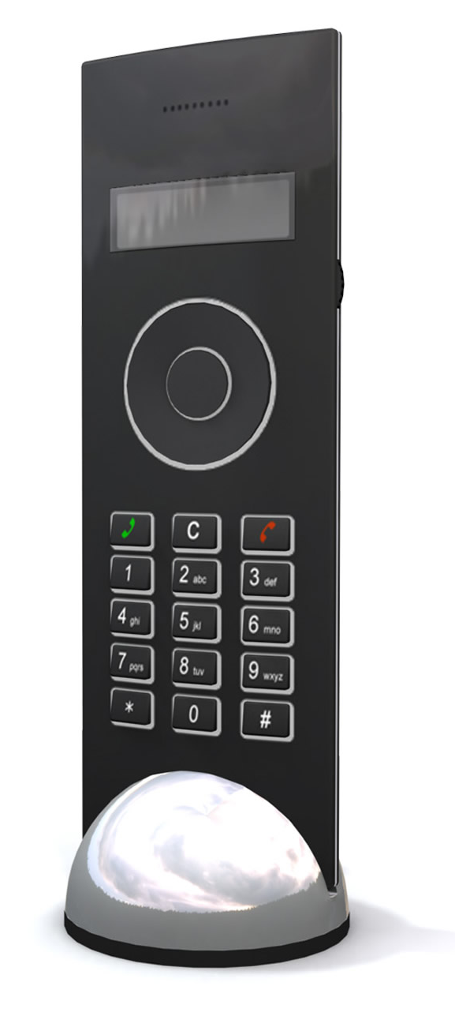
() Tab
Press to scroll the Skype™ tab
Up/Down
Adjust volume.
Left / Right
Scroll contacts
Dial / Answer
(1) Call out/Answer a call.
(2) Hold/release a call
Hang up
End talking/reject incoming call.
C: Delete Key
Delete wrongfully inputted numbers
/mute the microphone

2.2 Using Skype for the first time
(A) Simply insert the CD-ROM into the drive and install Skype from there (you will be connected to the Skype web page). Follow the onscreen instructions to download the software and proceed to install the program. It is highly recommended to install the latest version of Skype even if you already have Skype running on your computer. Using the CD enclosed will easily take you to the latest version of Skype.

If you have never used Skype before you will need to create a Skype account
(B) Run Skype and log in with Skype account.
You can create a Skype account as shown below:

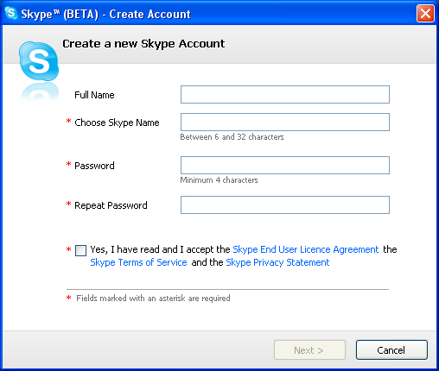

Follow the on screen instructions for selecting a name and password.
After software start-up, an icon will appear in the system tray as shown below:



This indicates that Skype has successfully connected to the Internet.


If the icon is shown as a grey icon with a cross through it, you have to check your Internet connection. This means that Skype could not connect to the internet.

2.3 Connecting the Slim LCD Phone to the PC
Before running the driver for the Slim LCD Phone, firstly connect the Slim LCD Phone to an available USB port on your computer.
NOTE: Skype must be running on your PC before connecting the Slim LCD phone to your PC.

2.4 Installing Universal Link™
(1) Insert the installation CD or download the Universal Link™ software from (www.instoreshop.com/support) – After completed download, please install the software. To install Universal Link™, Double click on the Universal Link Setup icon in the folder and follow the onscreen instructions.

(2) Run Universal Link™
Double-click on the icon on the desktop, the Skype program will pop up a window as shown below:

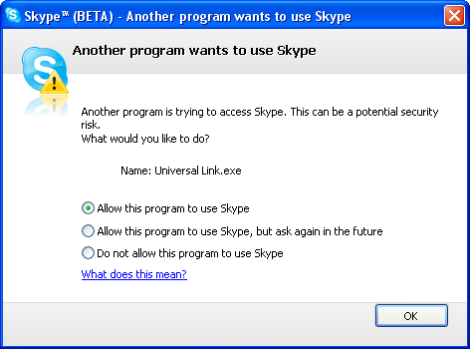

Select the first option “Allow this program to use Skype”, thereafter click on the “OK” button.
Note: If you have selected the wrong option, you can make another selection by following the FAQ. Please see 2.10 FAQ /problem4 for details.

After running Universal Link™, the icon will appear in the system tray as shown below:



 A green logo indicates the device and Skype are connected successfully.

If the icon is shown as a grey symbol, please run Skype first.

 If the icon is shown as a red symbol it means the Slim LCD Phone is connected incorrectly. Please reconnect the Slim LCD Phone.

2.5 How to call a Skype user from contact list
(1) Press “Tab” button to scroll to the Skype tab.
(2) Use the “Up & Down” buttons to select a contact.
(3) Press the “Call” button to initiate call.

2.6 Call Skype users via Speed-Dial
(1) Add "echo123" to Contacts
(2) Right click on the contact to assign a Speed-Dial for it, example "11"

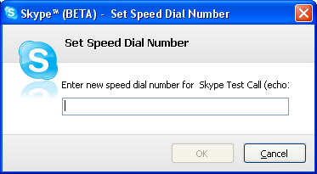

(3) Press the following digits "1+1" on the Slim LCD Phone, where after the number will be shown in the Skype window - Press on the “Call” button to initiate call.

2.7 Calling Regular Phones (Both landline & cell phones)
In order to call a regular phone please do the following:
Press "00" + "country number" + "phone number", then press the “Call” button

Example: To call someone in the UK (Country code 44):

00 + 44 + 12345678, and then press the “Call” button

Note: In order to use this function, you must buy SkypeOut Credit from www.skype.com

2.8 Answer a call
When a call comes in, the Slim LCD Phone will ring. Press the “Call” button to answer the call, or press on the “Hang up” button to reject the call.

2.9 Advanced
(1) Right click the icon in the system tray and select Advanced Options

(2) The window is shown as below:

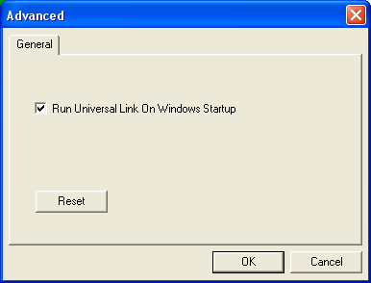

(3) Run Universal Link On Windows start-up: Select to enable this feature.
The Universal Link™ will be launched automatically when Windows starts.

2.10 Setting the Volume
1. Double click on the logo in the system tray. Hereafter the following screen will appear: Use the increase and decrease buttons to set the volume. This can be done for both the Microphone and the Speaker volume.

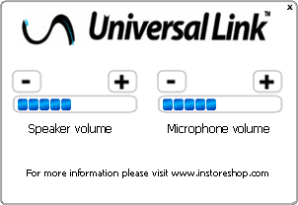

2.11 FAQ

Problem 1
When I make or receive calls on Skype I cannot hear the people speaking or they cannot hear my voice through the Slim LCD Phone.

Solution
In the Skype Client, go to “Tools->Options->Sound Devices” and open the window as shown below: Set “Audio In” and “Audio Out” to “USB Audio Device”.

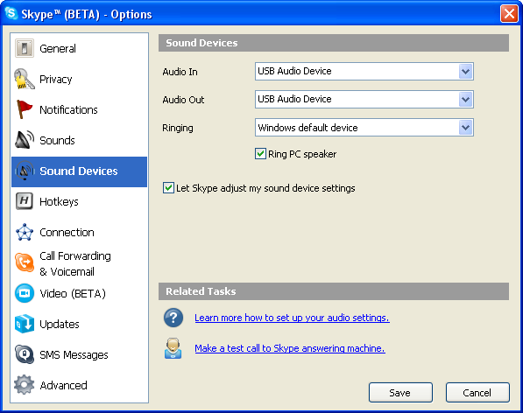

Problem 2
Skype is running, but the icon of Universal Link™ still show as

Solution
You have selected the wrong option when you installed Universal Link™ (Slim LCD Phone Driver). In the Skype Client, go to “Tools -> Options -> Privacy -> “Manage other programs’ access to Skype”.

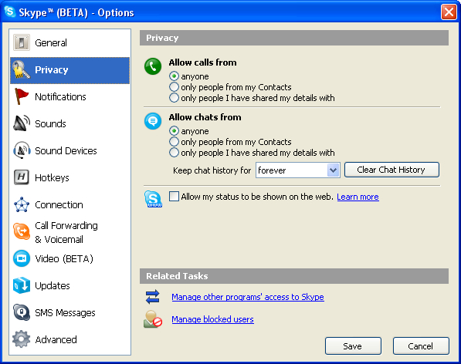

Select the correct option, click on the “Change” button to open the “Manage API Access Control” window, and make another selection. “Allow Universal Link.exe to access Skype”.

For more troubleshooting and the latest drivers, please check:

www.instoreshop.com

